Design of Low Pass Filter using Windowing Techniques
4.3. Design and Analysis of an FIR Low-Pass Filter Using the Hanning Window Technique in MATLAB

Program(MATLAB Code)
clc;
clear;
close all;
%% --- Input Parameters ---
fp = 1000; % Passband cutoff (Hz)
fs = 4000; % Sampling frequency (Hz)
N = 50; % Filter order (even number preferred)
wc = fp/(fs/2); % Normalized cutoff frequency (0 to 1)
%% --- FIR Low Pass using Hanning Window ---
b_hann = fir1(N, wc, 'low', hanning(N+1));
disp('--- Hanning Window Coefficients ---');
disp(b_hann');
%% --- Plot Frequency Responses ---
figure;
freqz(b_hann,1);
title('Low-pass FIR using Hanning Window');

Output
--- Hanning Window Coefficients ---
0.0000
0
-0.0004
0
0.0013
0
-0.0028
0
0.0050
0
-0.0081
0
0.0122
0
-0.0179
0
0.0259
0
-0.0378
0
0.0580
0
-0.1027
0
0.3172
0.5000
0.3172
0
-0.1027
0
0.0580
0
-0.0378
0
0.0259
0
-0.0179
0
0.0122
0
-0.0081
0
0.0050
0
-0.0028
0
0.0013
0
-0.0004
0
0.0000

Fig 1
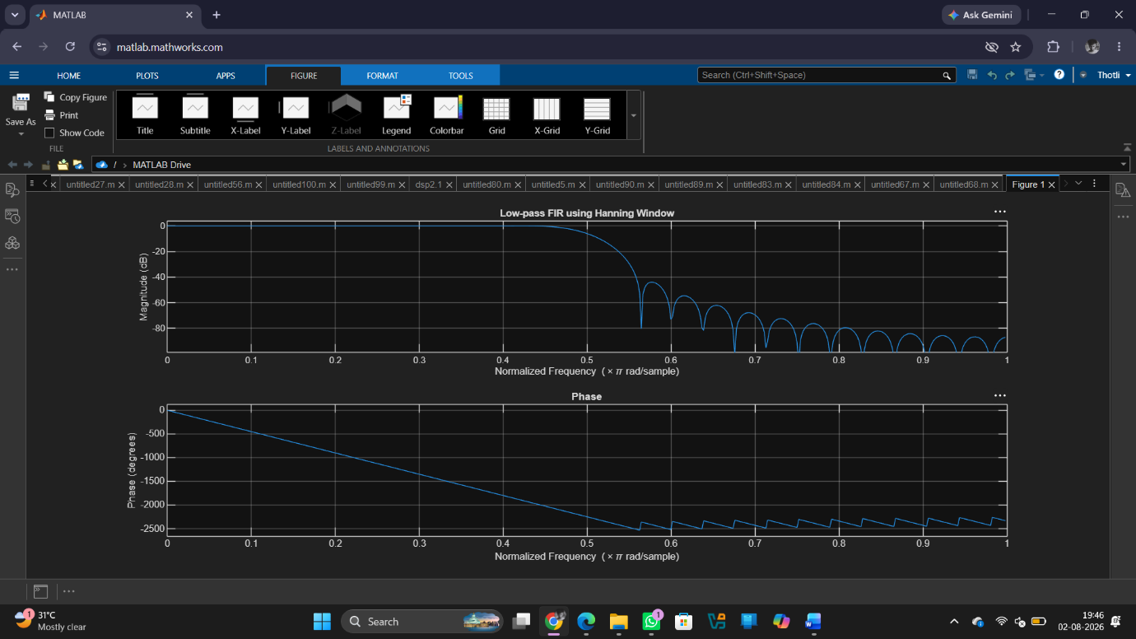

Result
1. The FIR Low-Pass Filter was successfully designed using the Hanning Window technique for the specified filter parameters.
2. The FIR filter coefficients were generated and implemented successfully in MATLAB.
3. The magnitude and phase responses of the designed filter were obtained and analysed.
4. The filter exhibited the desired low-pass characteristics with reduced sidelobes and improved stopband attenuation compared to the Rectangular Window method.

